MMI – Mortgage Market Intelligence
Completed by E360 Help Desk
Screen shots, with identifier above the screen shot, so QC person(s) can identify what the screen shot is for. Emails requesting account set up/termination must be added to the ticket for audit purposes.

Setup
Access: Branch Managers and above. Request for access to LO’s/LOA’s must be sent to Scott Brown for approval.
Click https://mmi.run/l/intelligence
Click “Manage Seats” from the hamburger menu
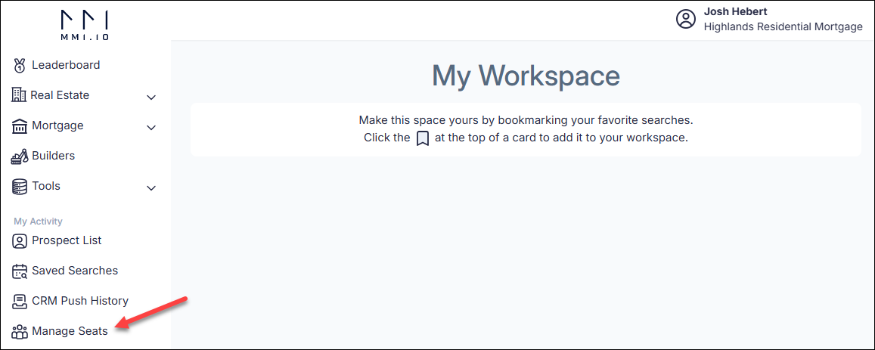

Click “Add Team Member” tab
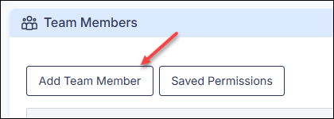

Enter First Name, Last Name, Mobile Number, Email address and NMLS (if Loan Officer)
Permissions for Loan Officers:
Permissions | Notes
Agent Tracking Alerts
Builder Research
Company Wallet Share | Granted to Branch Managers, Executive and Recruiter staff Only
Loan Officer Tools
Manual Property Monitoring
Past Property Tracking Alerts
Property/County research
Title Explorer
View LO Contact Details
Wholesale Insights | Granted to Executive and Recruiter staff only

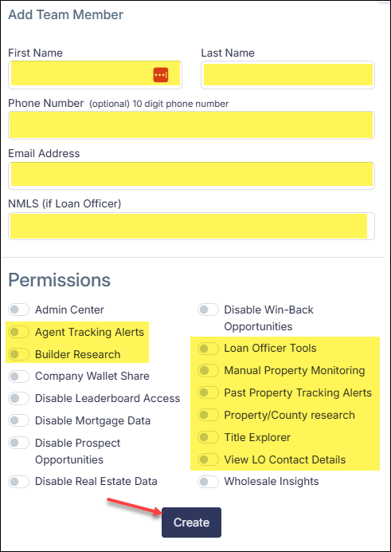
Click “Create”
Once user created, Search for user and take screenshot of account active

